I register my users using an object and a method for inserting them into the database, see documentation on code for more information. Steps where taken to ensure users do not insert faulty data and toasts where made to inform users of their mistakes.

Register GUI on Pixel 2 emulator.

I used various methods and queries to check the validity of the username and password in login, see code for further detail. Toasts where also made to tell the user when incorrect data was inserted into the login, see code for more details.

Screenshot of GUI for login activity.

Table for storing users in my database.

Data inside of the database.

This is the GUI that displays the flights and all the flights information that can be booked by clicking the book flight button. Relevant error catching is implemented for when a user has insufficient funds, flight is fully booked, or if the user mistakenly clicked the book flight button without choosing a record.

Database for storing flight information.

Data stored in the flight table.

GUI for accounts page where all of the account information can be viewed, funds added, logout, view all of the users flights, as swell as cancel those flights. When adding funds a popup will appear which asks for amount. Error catching was implemented for all features such as when a user does not enter an amount for adding funds it will show a message to guide the user, error catching has also been implemented in the cancel flight button for when the user mistakenly clicks the cancel button without having a flight selected.

Popup for adding funds after add funds button on account page has been clicked.

GUI for viewing all passengers on a certain flight, error catching has been implemented so that the app wont crash when wrong input has been added into editText. Users can search by flight ID to see all of the users that has booked a flight.

Architecture model for FlyBy flight booking system.

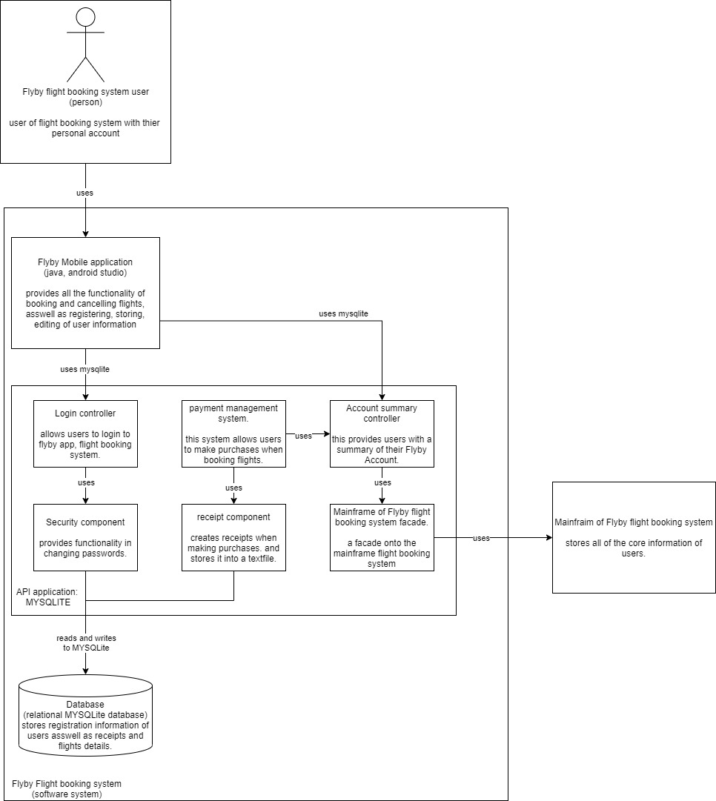

Table where the receipt and purchase info is stored.

Data stored inside of table.

Receipt inside of textfile.

The system has been implemented into the airline reservation system and when a user tries to make a purchase that is more than their balance a toast is made to tell the user that they have insufficient funds in their account.